Please distribute this alert to any users within your agency who are responsible for utilizing or changing work addresses in SAP, E-PAR or IRIS.

Work Address Changes in SAP, E-PAR and IRIS

- Information regarding changes to the work address fields in SAP, E-PAR and IRIS.

Work address fields have been changed in SAP, E-PAR and IRIS to support a Governor’s Office initiative to standardize work addresses.

Effective Sunday, June 16, 2024, organization and position work addresses will correspond to an official work address record from the DGS TRIRIGA real estate application.

SAP Changes
On Sunday, June 16, 2024, existing Address Infotype (IT1028), Subtype “Main address” records will be updated to include a TRIRIGA location ID on the organization and on the position. The TRIRIGA location ID will automatically populate the work address. Auto-populated fields cannot be edited.

New Field:
Location/Building - contains a unique Location or Building ID that corresponds to a work address record from the DGS TRIRIGA real estate application. Entering the Building ID in the Location/Building field will cause the work address fields to auto-populate.

Field being repurposed:
Address suppl. - contains the Parent Property assigned to the work address in the DGS TRIRIGA real estate application. The Parent Property is a higher-level designation for work locations. For example, multiple work locations or buildings are often grouped under the same Parent Property (e.g., Keystone Industrial Park, Bald Eagle State Forest, etc.). The Address suppl. (i.e., Parent Property) will automatically populate based on the Location/Building entered or selected.

Affected SAP transactions:
PO10
PO13
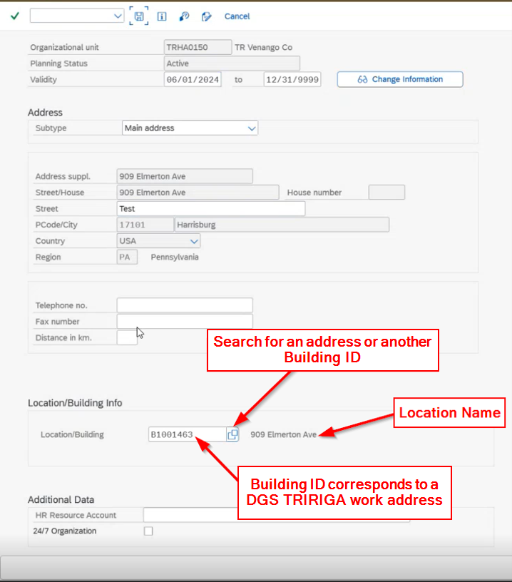

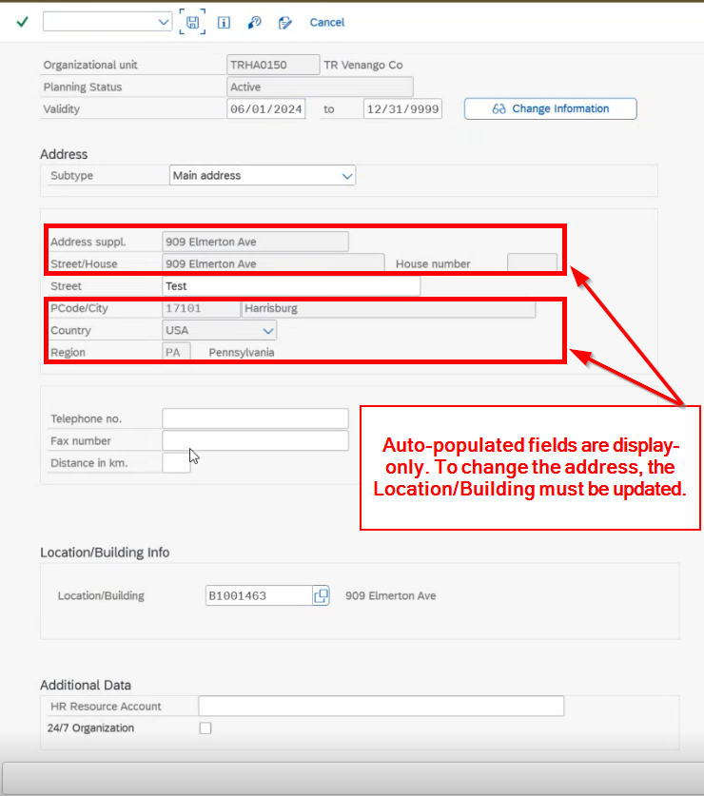
To enter home addresses as work locations for Home-headquartered positions, “HHQ” must be entered or selected from the Location/Building search. Once “HHQ” is entered or selected in the Location/Building field, the Address suppl. field will automatically populate “HHQ – Home Headquartered” and the remaining address fields will unlock and can be manually edited.
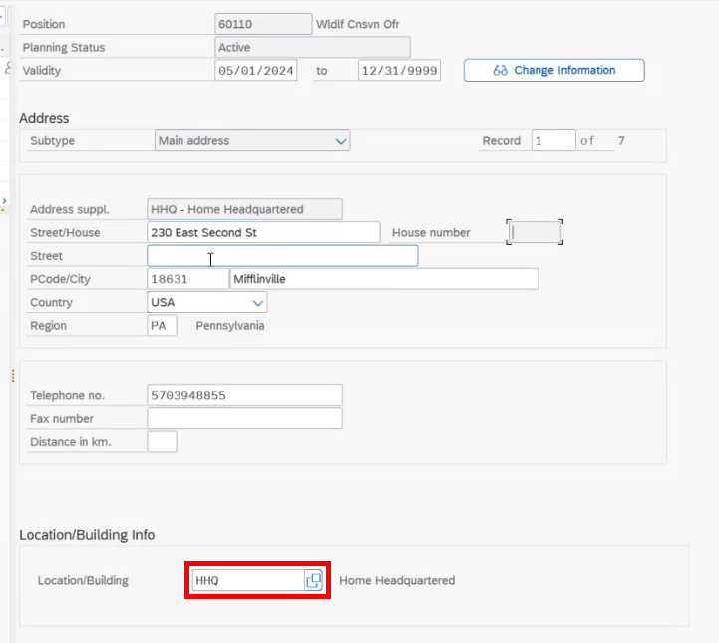

Related E-PAR Changes
The “Work Address” section on the “Fill a Vacant Position” E-PAR form will no longer be manually entered. A DGS TRIRIGA address must be selected, and the address fields will automatically populate.

New Fields:
Home Headquartered checkbox - for any true home-headquartered position, selecting the checkbox will populate “HHQ – Home Headquartered” into the “Parent Property” field. Home-headquartered work addresses can be manually entered into the address fields.

Parent Property - a higher level designation for work locations (e.g., Keystone Industrial Park, Bald Eagle State Forest, etc.).

Location ID - contains the unique location or building ID assigned to the work address in the DGS TRIRIGA real estate application (does not apply to home headquarter positions).

Location Name - contains the unique building or location name assigned to the work address in the DGS TRIRIGA real estate application (does not apply to home headquarter positions).

Edit Location button - select the button to search for a DGS TRIRIGA work address. Once the address is selected, the work address fields will automatically populate. Unless the address is home-headquartered, only “Address 2” can be edited.

Affected E-PAR action types:
Fill a Vacant Position
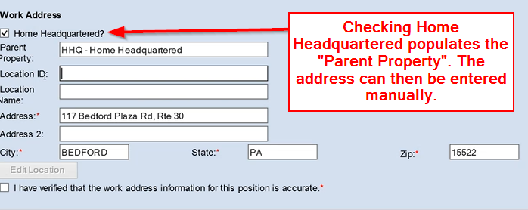

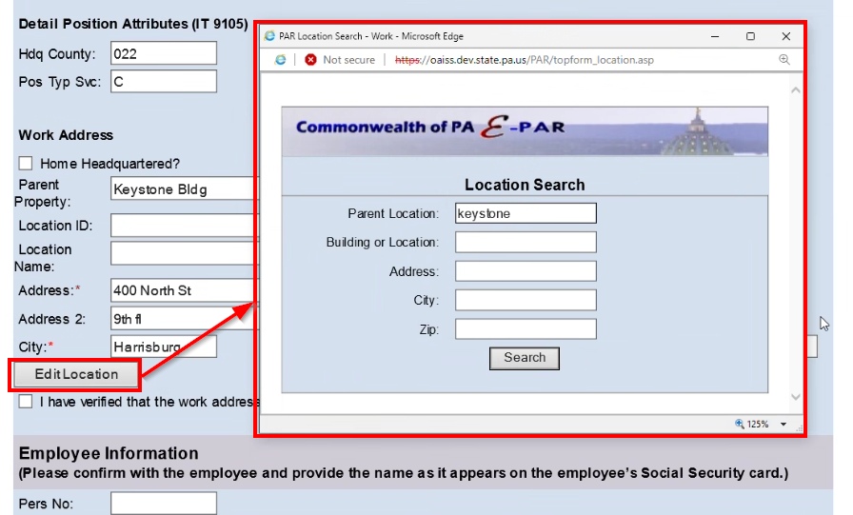

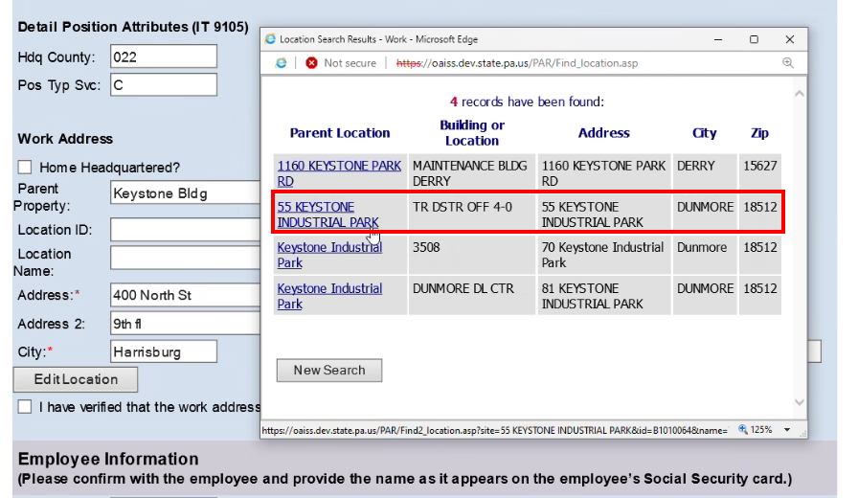
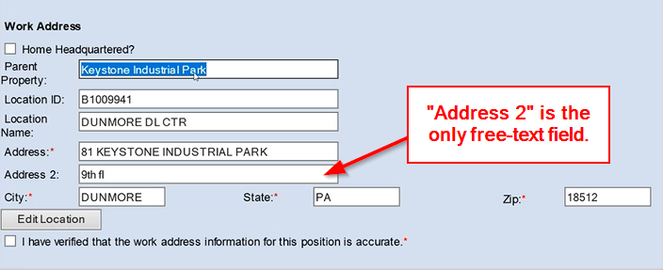

Related IRIS Changes
To support a Governor’s Office initiative, the following two new work address fields have been added to the IRIS views indicated below (NOTE: to see the new fields, you will need to relink or refresh your link to these views in any MS Access database being used). In addition, the ADDRESS_SUPP field has been repurposed as described below:

New fields:
LOCATION_ID - contains the unique building or location ID assigned to the work address in the DGS TRIRIGA real estate application.

LOCATION_NAME - contains the unique building or location name assigned to the work address in the DGS TRIRIGA real estate application.

Field being repurposed:
ADDRESS_SUPP - until now, this field has been used to record the building name associated with a work address. Moving forward, this field will reflect the Parent Property associated with the work address in the DGS TRIRIGA real estate application.

Affected IRIS views:
PPI_SAP_ORG_IRIS
PPI_SAP_WFT_POS_IRIS

Questions?
If you have any questions regarding Work Address Changes in SAP, E-PAR and IRIS, please submit an AskHR HR Application Support case.

